**Plumsmart Services**

**1. Home Page**

**Headline:  
*Logo***

**Subheading:  
*"Reliable, affordable, and fast plumbing solutions for your home and business."***

**Button for “Request a Quote”  
*"Call PlumSmart for 24/7 Emergency Service" 0455503660 + ali@plumsmart.com.au***

**Services Highlight: - Static**

* **Residential Plumbing**
* **Emergency Plumbing**
* **Maintenance**
* **Blockages**
* **Problem Diagnosis**

**Links to Social Media Pages - Buttons**

[**https://www.facebook.com/share/SSV1z91yHNxuFj9T/?mibextid=LQQJ4d**](https://www.facebook.com/share/SSV1z91yHNxuFj9T/?mibextid=LQQJ4d)

[**https://www.instagram.com/plumsmartservices?igsh=MWVwc242d2oyMHB5dg%3D%3D&utm_source=qr**](https://www.instagram.com/plumsmartservices?igsh=MWVwc242d2oyMHB5dg%3D%3D&utm_source=qr)

**2. About Us - Part of subheading**

**Who We Are:  
*"At PlumSmart Services, we bring over 20 years of plumbing expertise to the table. Our mission is to provide high-quality service to homeowners and businesses Sydney Wide. We pride ourselves on delivering exceptional workmanship and customer satisfaction."***

**Why Choose PlumSmart?**

* **Licensed and insured**
* **24/7 emergency services**
* **Trusted local professionals**
* **Affordable pricing**
* **Honesty & pride in our work**
* **Mission Statement:  
  *"At PlumSmart Services, our goal is to provide smart plumbing solutions that are both efficient and budget-friendly, while maintaining long-lasting relationships with our customers."***

**3. Services Page - Part of subheading**

**Intro Text:  
*"PlumSmart Services offers comprehensive plumbing services for residential properties. Whether you need a quick fix or a major installation, our team is here to help."***

**Residential Plumbing:  
*"From fixing leaky faucets to upgrading water heaters, PlumSmart Services keeps your home’s plumbing in top shape."***

* **Drain cleaning and blockages**
* **Water heater installation & repair**
* **Leak detection & repair**
* **Faucet and toilet repairs**
* **Drain Replacement**
* **Stormwater Works**
* **LPG & Natural Gas**
* **New Builds**
* **Granny Flats & Renovations**
* **Maintenance**
* **camera inspection**

**Emergency Plumbing: Part of subheading  
*"Plumbing emergencies don’t follow a schedule, and neither do we. Call PlumSmart 24/7 for fast emergency service."***

**Preventative Maintenance:  
*"Keep your plumbing running smoothly year-round with our maintenance packages. PlumSmart Services provides detailed inspections to prevent costly repairs down the road."***

**5. Contact Page – Part of subheading**

**Call-to-Action:  
*"Contact PlumSmart Services today for a free estimate or emergency plumbing help."*  
Contact Form Fields:**

* **Ali Reda**
* **ali@plumsmart.com.au**
* **0455503660**
* **Message (optional)  
  Contact Info Display:**
* **Phone number (with a click-to-call button)**
* **Email address**
* **Physical location (if applicable)**
* **Operating Hours:  
  *"PlumSmart Services is available 24/7 for emergency plumbing."***

**Service Areas:  
*"We proudly serve Sydney and surrounding areas."***

**7. Projects Page – Button on Home page**

***"At PlumSmart Services, we specialize in residential plumbing and maintenance, ensuring that your home’s plumbing system runs smoothly. From diagnosing hot water issues to clearing stubborn blockages, here are some recent projects that demonstrate our commitment to high-quality service and customer satisfaction."***

**Project 1: Full Home Re-piping**

* **Client Type: Residential**
* **Project Overview: *We replaced the old, earthenware piping that was original from the 70’s to the house existing sewer boundary with PLASTIC DWV PIPES***
* **Challenges: *Limited access on the side of the house  a tricky job, but we got it done the old ways shovel in hand digging we went***
* **Outcome: *Improved water flow, piece of mind,  satisfied homeowner!***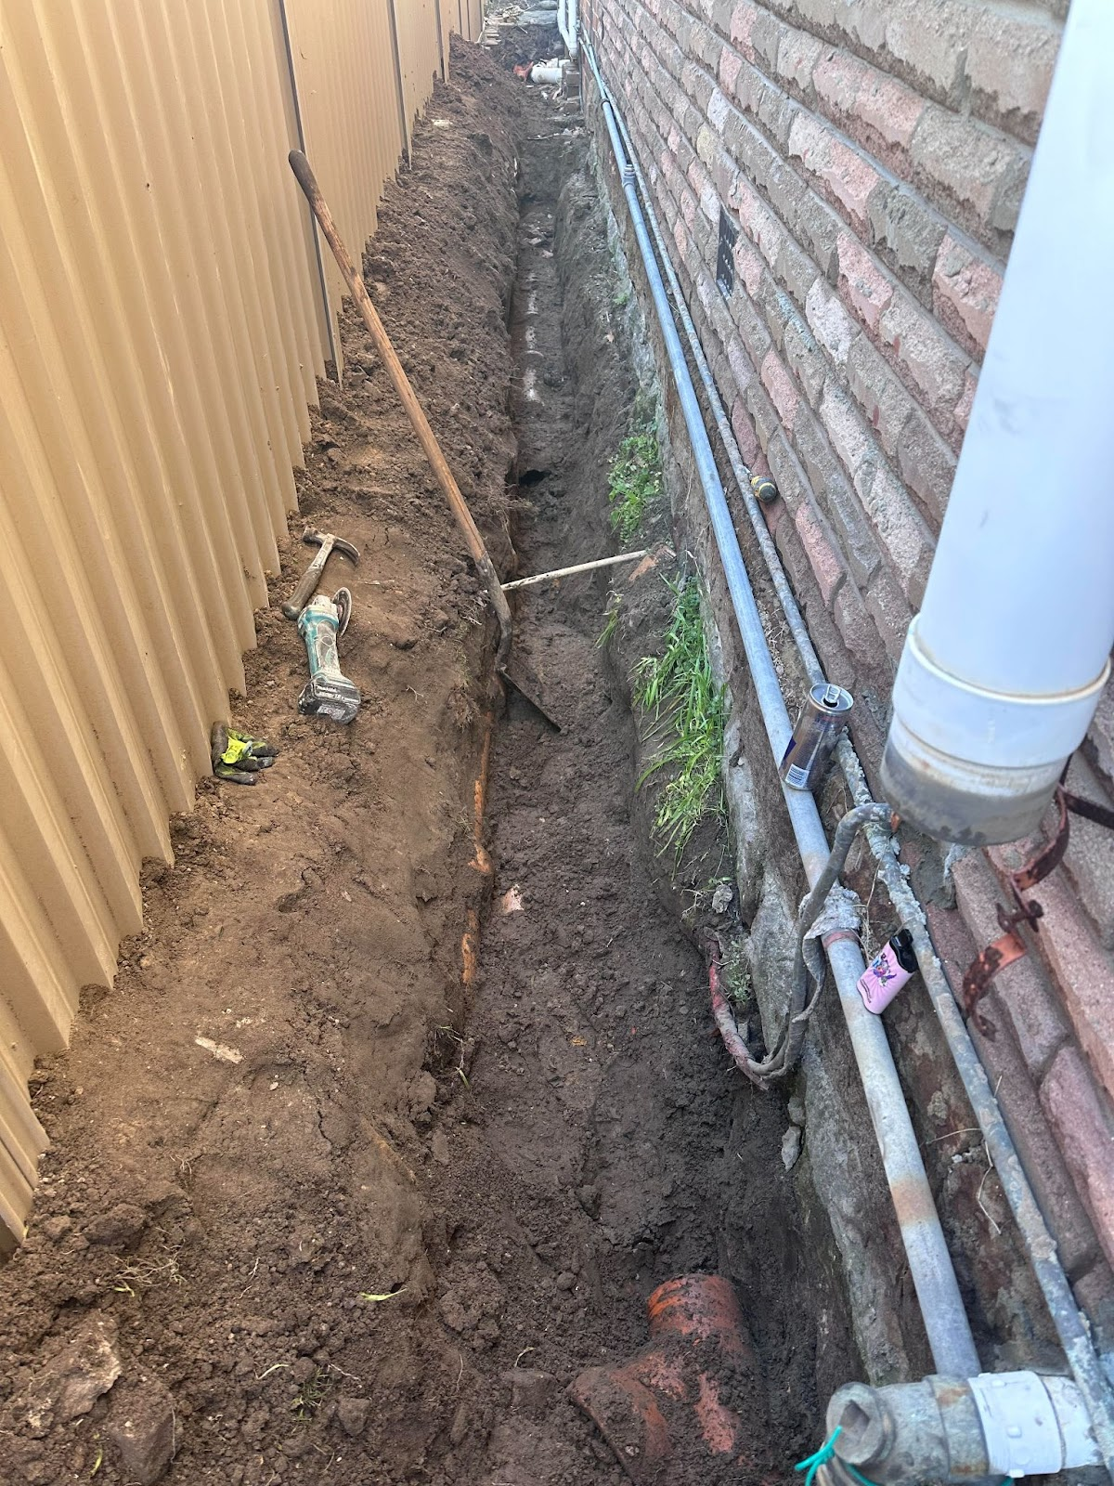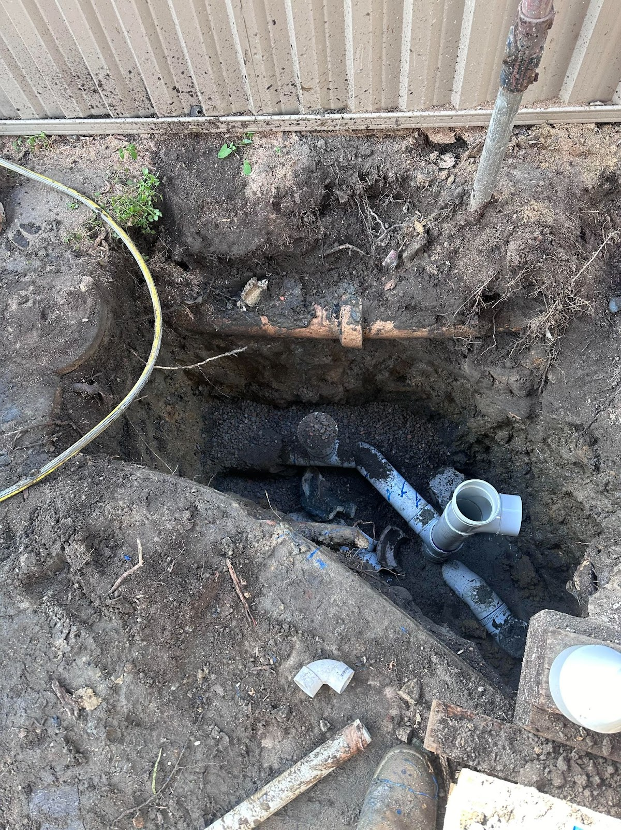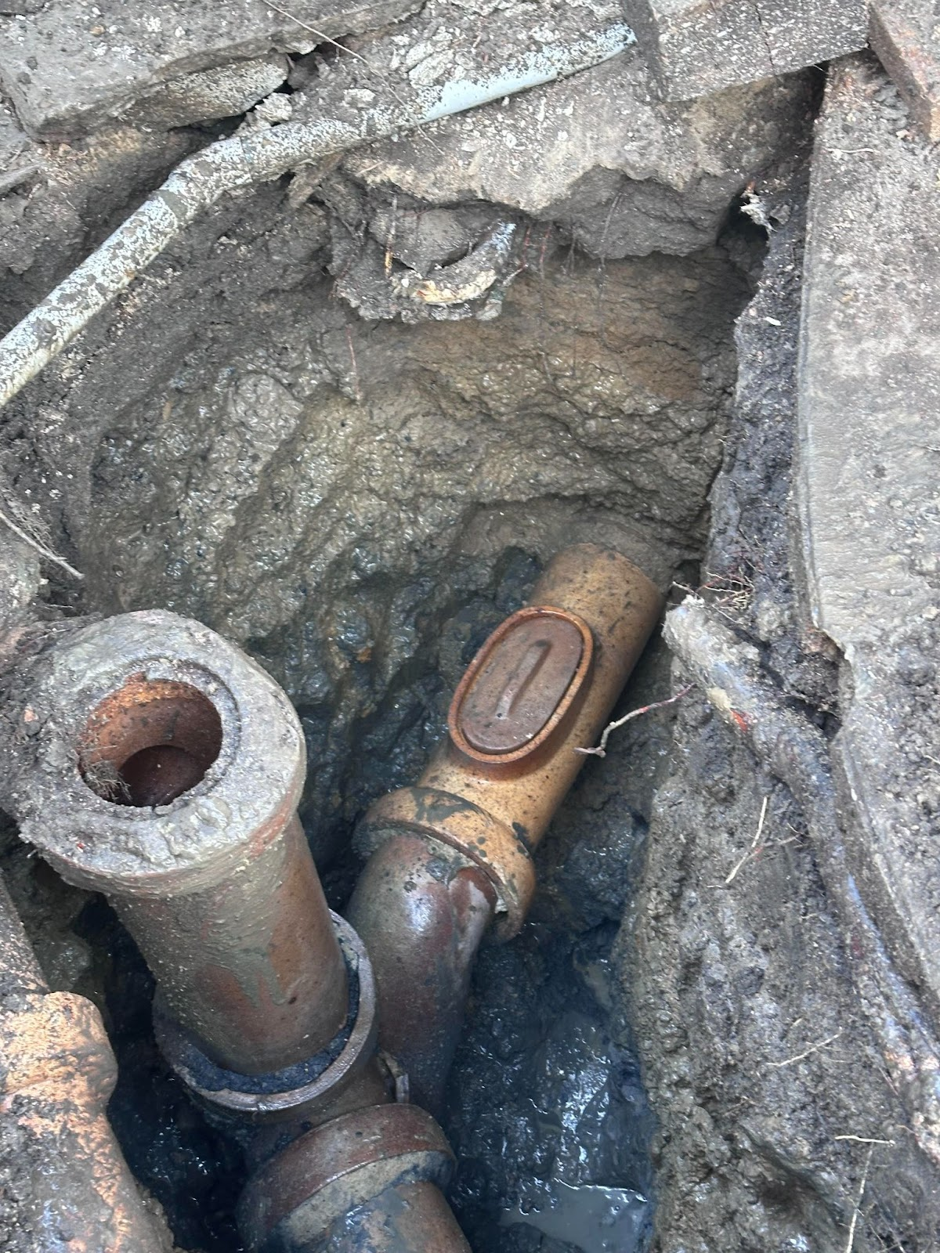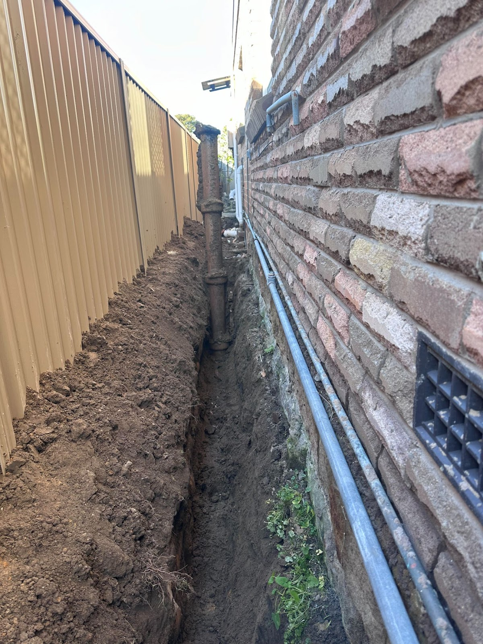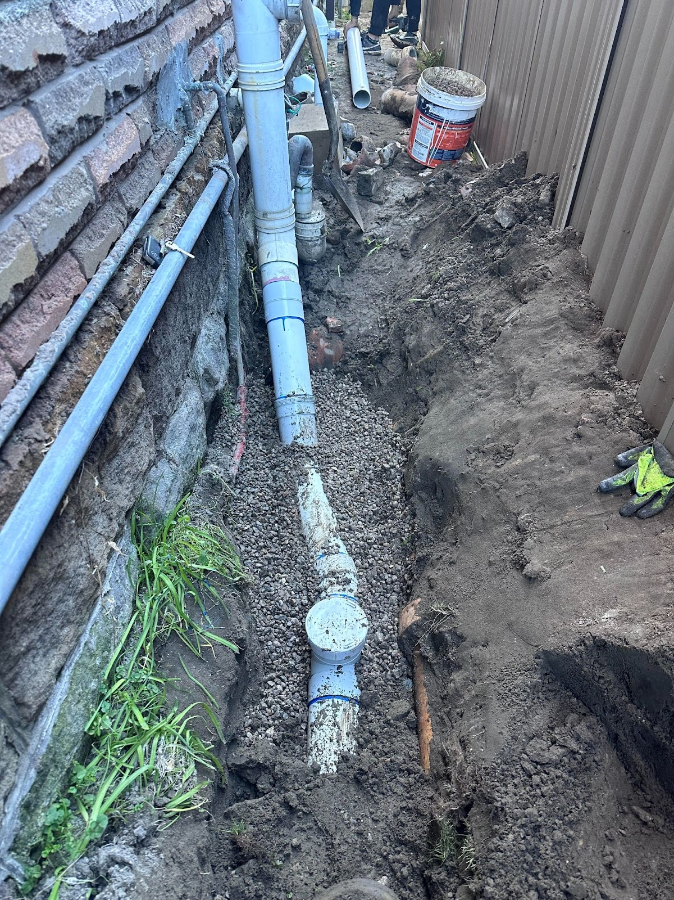

**Project 2: Emergency Water Heater Replacement – [Location]**

* **Client Type: Residential**
* **Project Overview: *Our team responded to an emergency water heater failure. We quickly assessed the situation and replaced the faulty unit with a new energy-efficient model, ensuring the homeowner had hot water restored within hours.***
* **Challenges: keeping the customer stress free from the whole ordeal**
* **Outcome: *Happy homeowner with a new, efficient water heater.***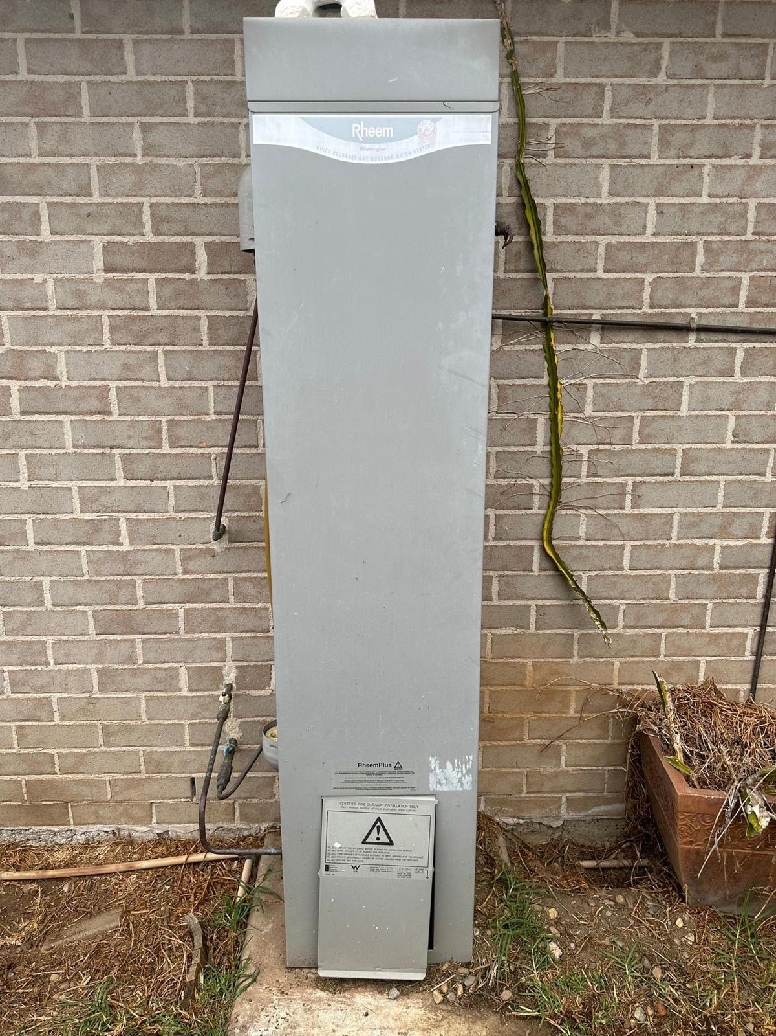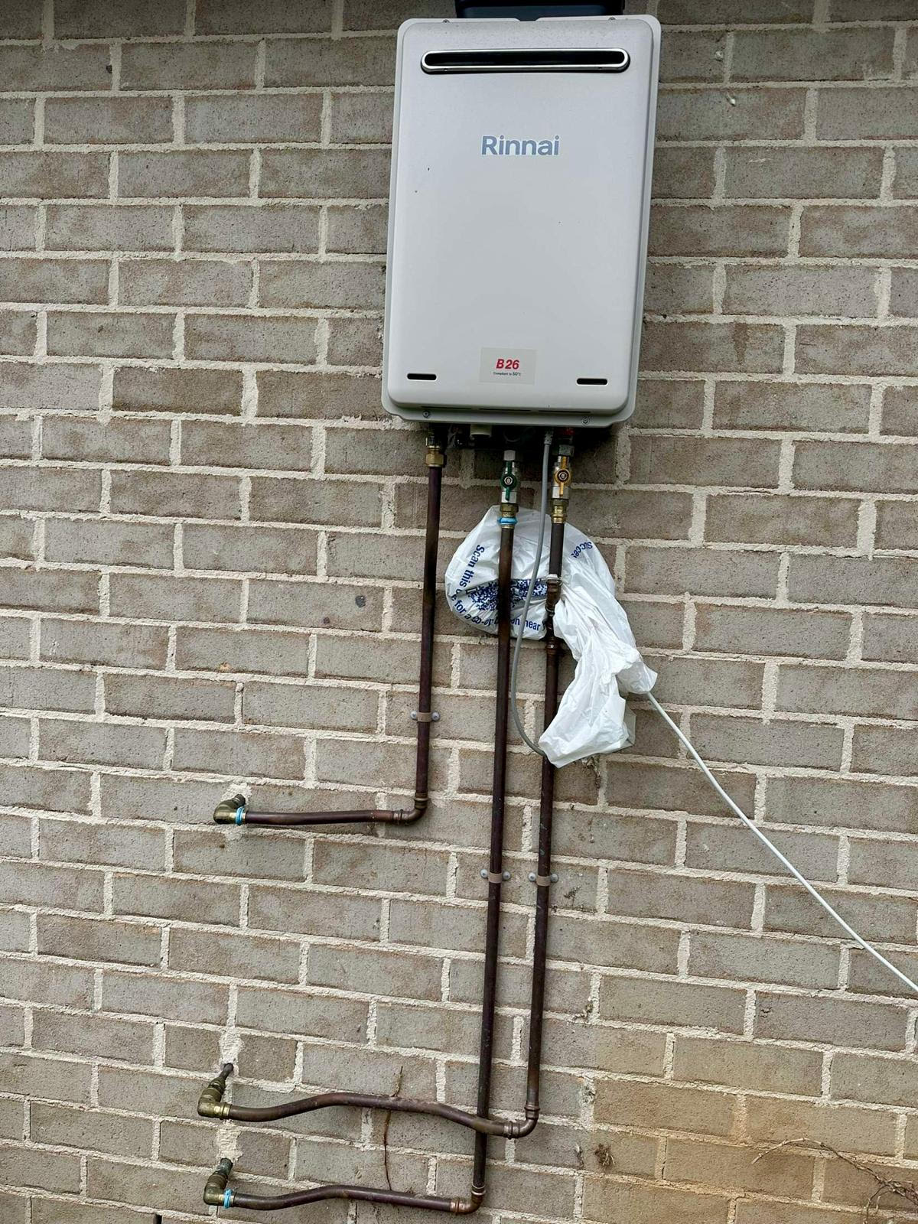

**Project 3: guttering overflowing**

* **Client Type: residential**
* **Project Overview: *We designed and installed a custom drainage system  to give relief to the guttering system surrounding the house***
* **Challenges: *Heavy rains during the project required us to implement additional protective measures while working.***
* **Outcome: *A robust drainage system that effectively manages runoff and prevents flooding.***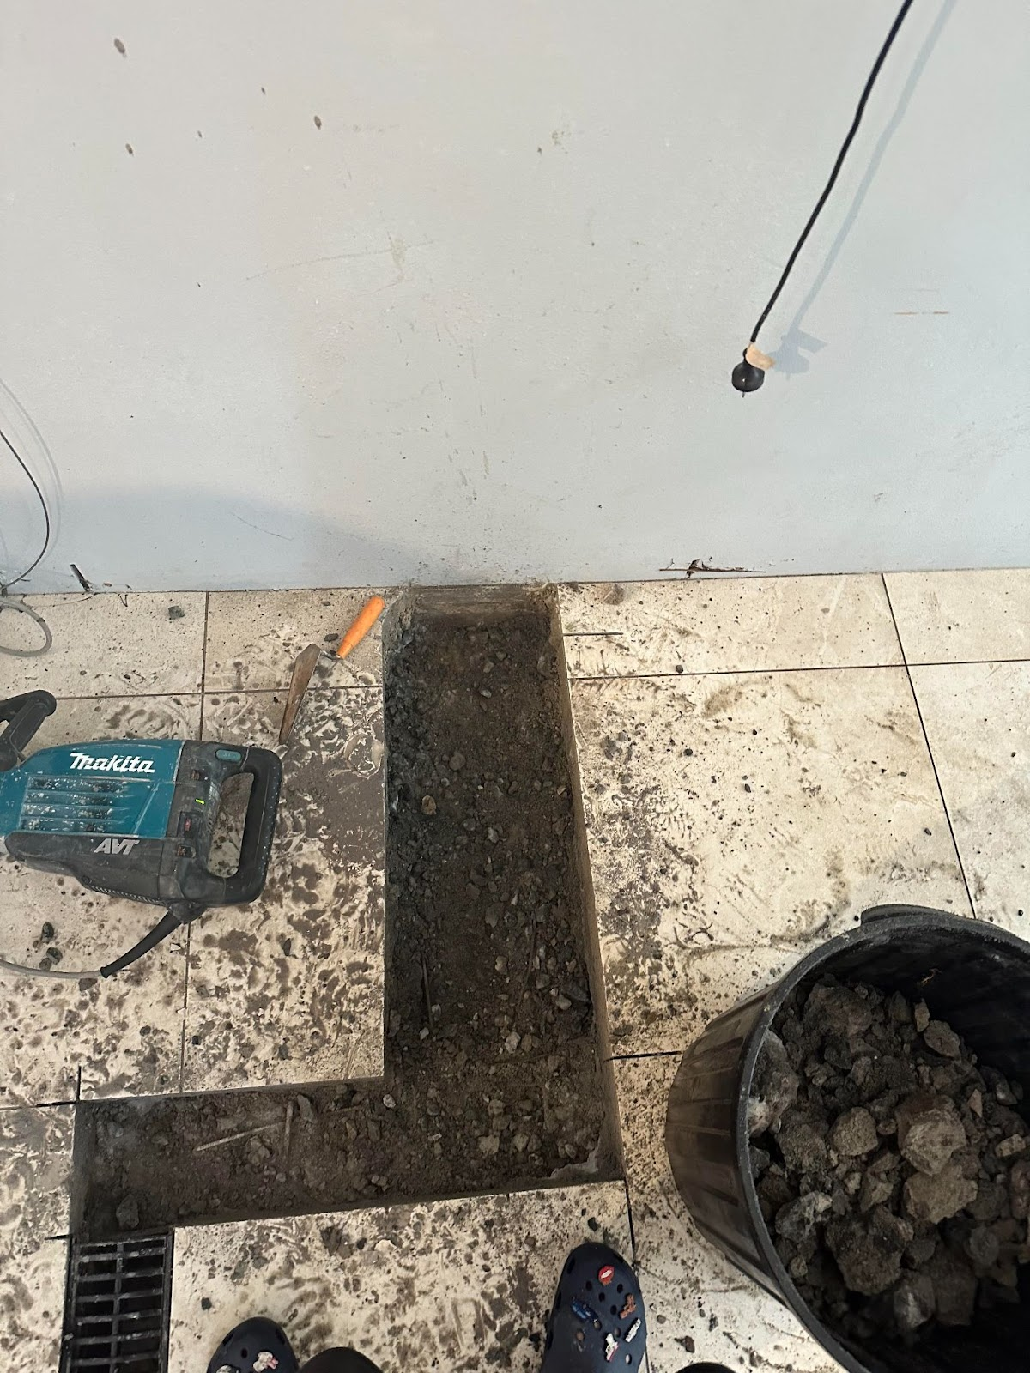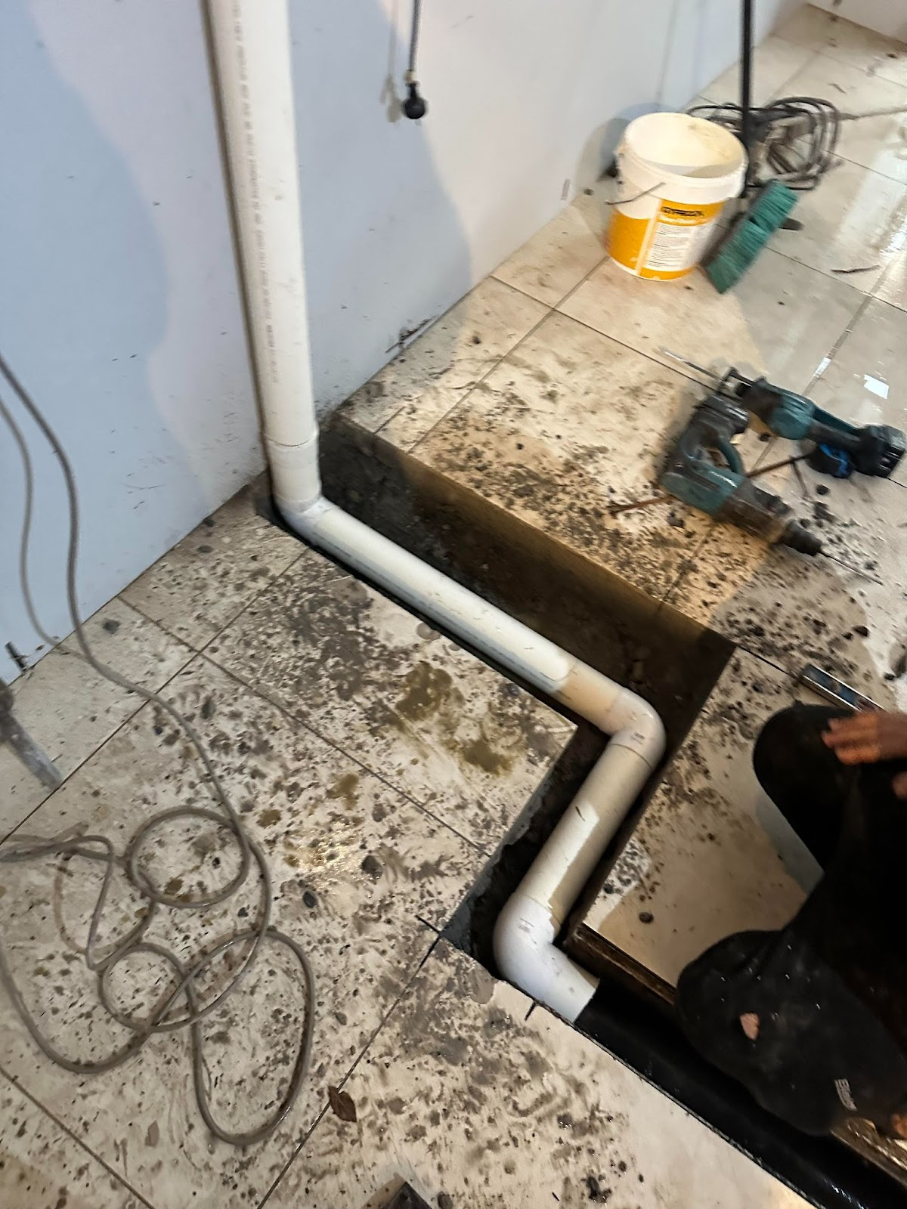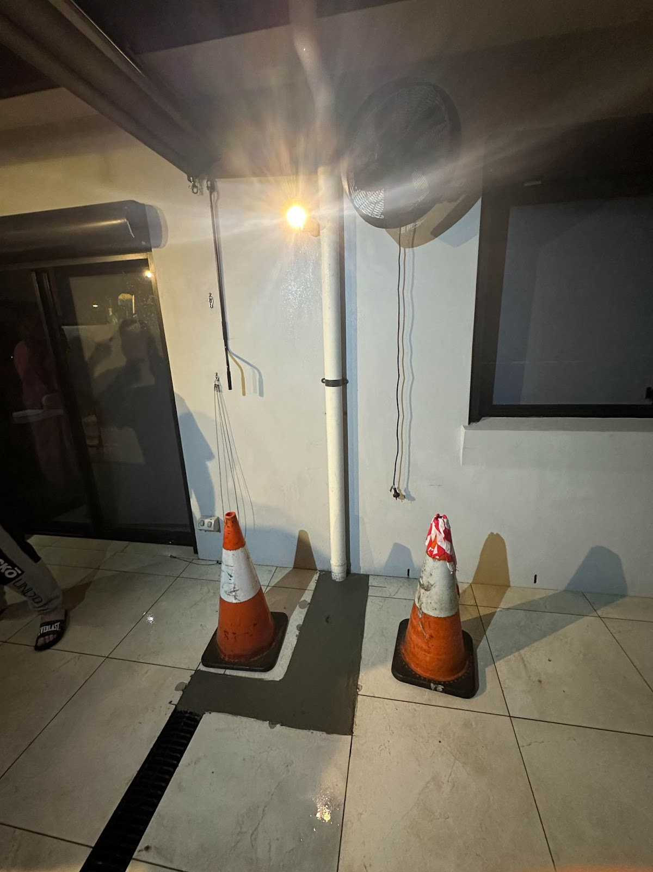

**Project 4:Water meter repair**

* **Client Type: Residential**
* **Project Overview: *Our team was called to emergency the wife had drove over the water metre***
* **Challenges: *Accessing and replacing the damaged metre***
* **Outcome: *Restored water to house with a new setup and garden tap***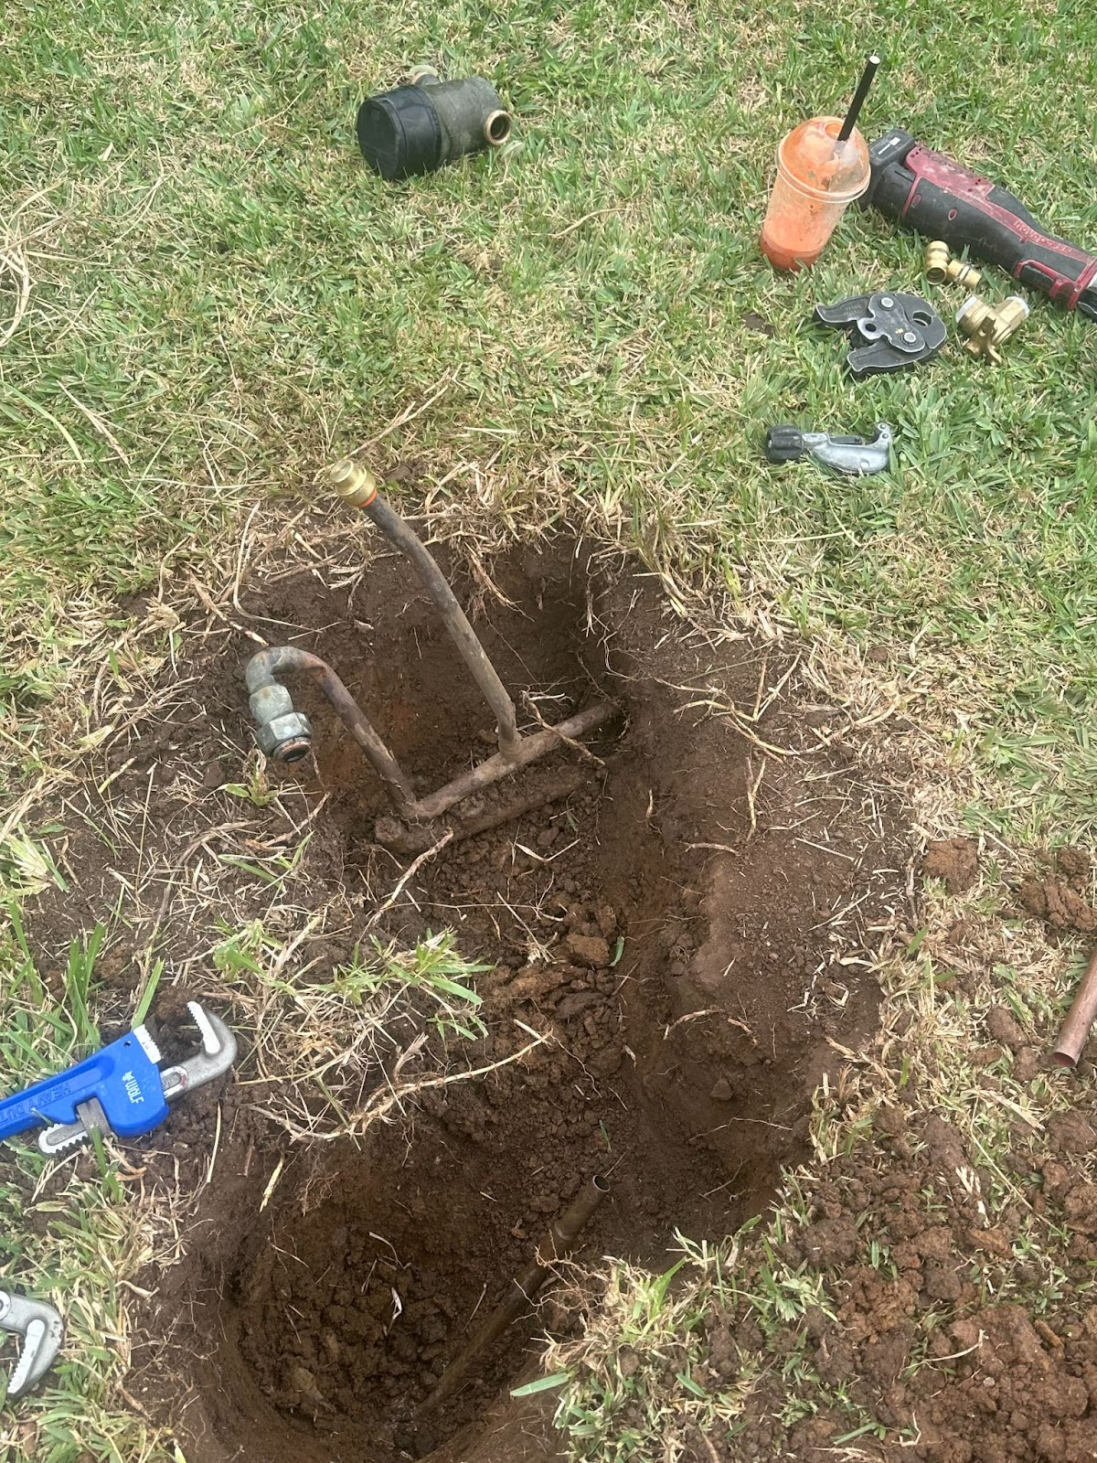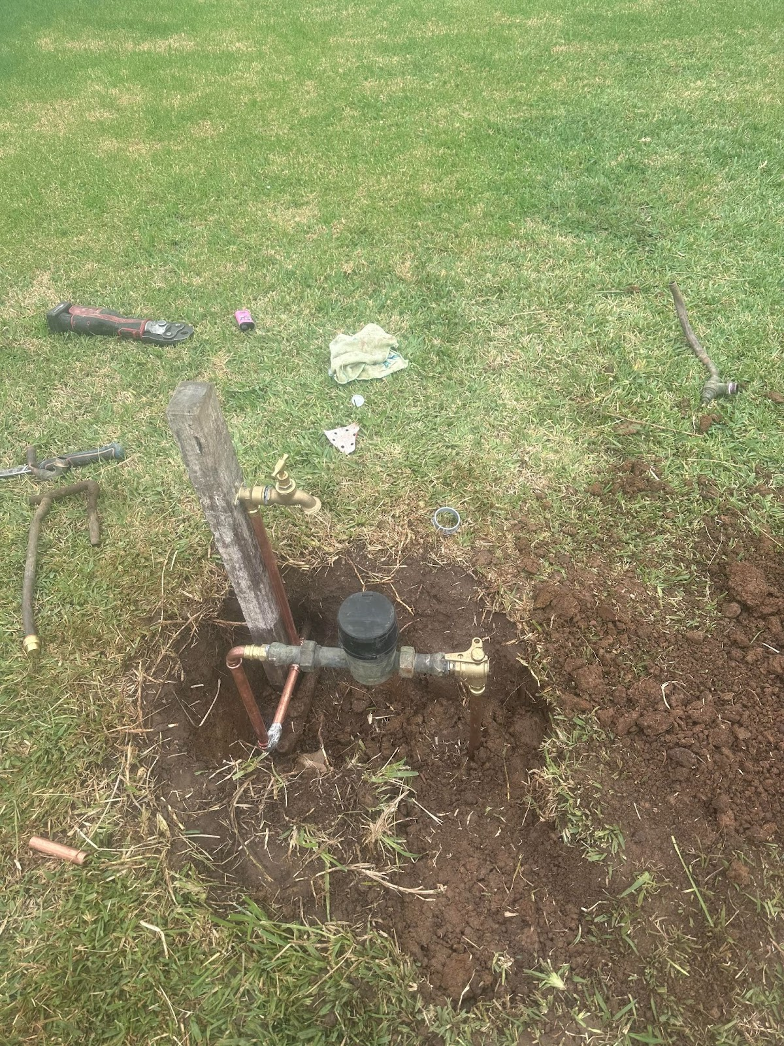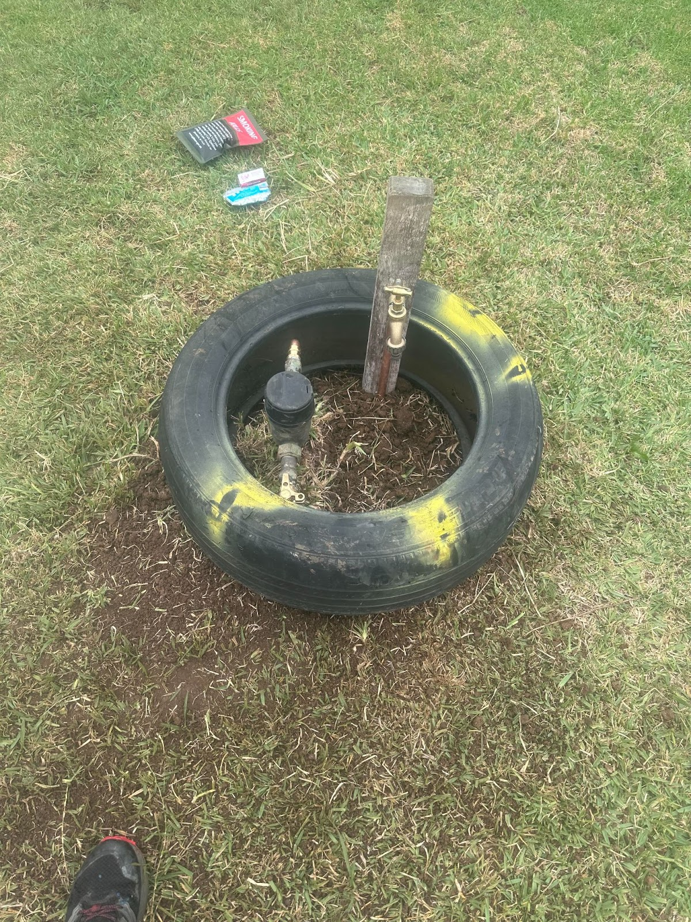

**Project 5: Blocked Drain Clearance**

* **Client Type: coffee shop**
* **Project Overview: *The customer experienced a slow-draining kitchen sink. We performed a camera inspection and found a significant grease blockage. Using hydro-jetting, we cleared the blockage and recommended maintenance tips to prevent future issues.***
* **Challenges: *Ensuring minimal disruption to the customer's daily routine while performing the job.***
* **Duration: *2 hours***
* **Outcome: *Fully restored drainage with a smooth, free-flowing sink.***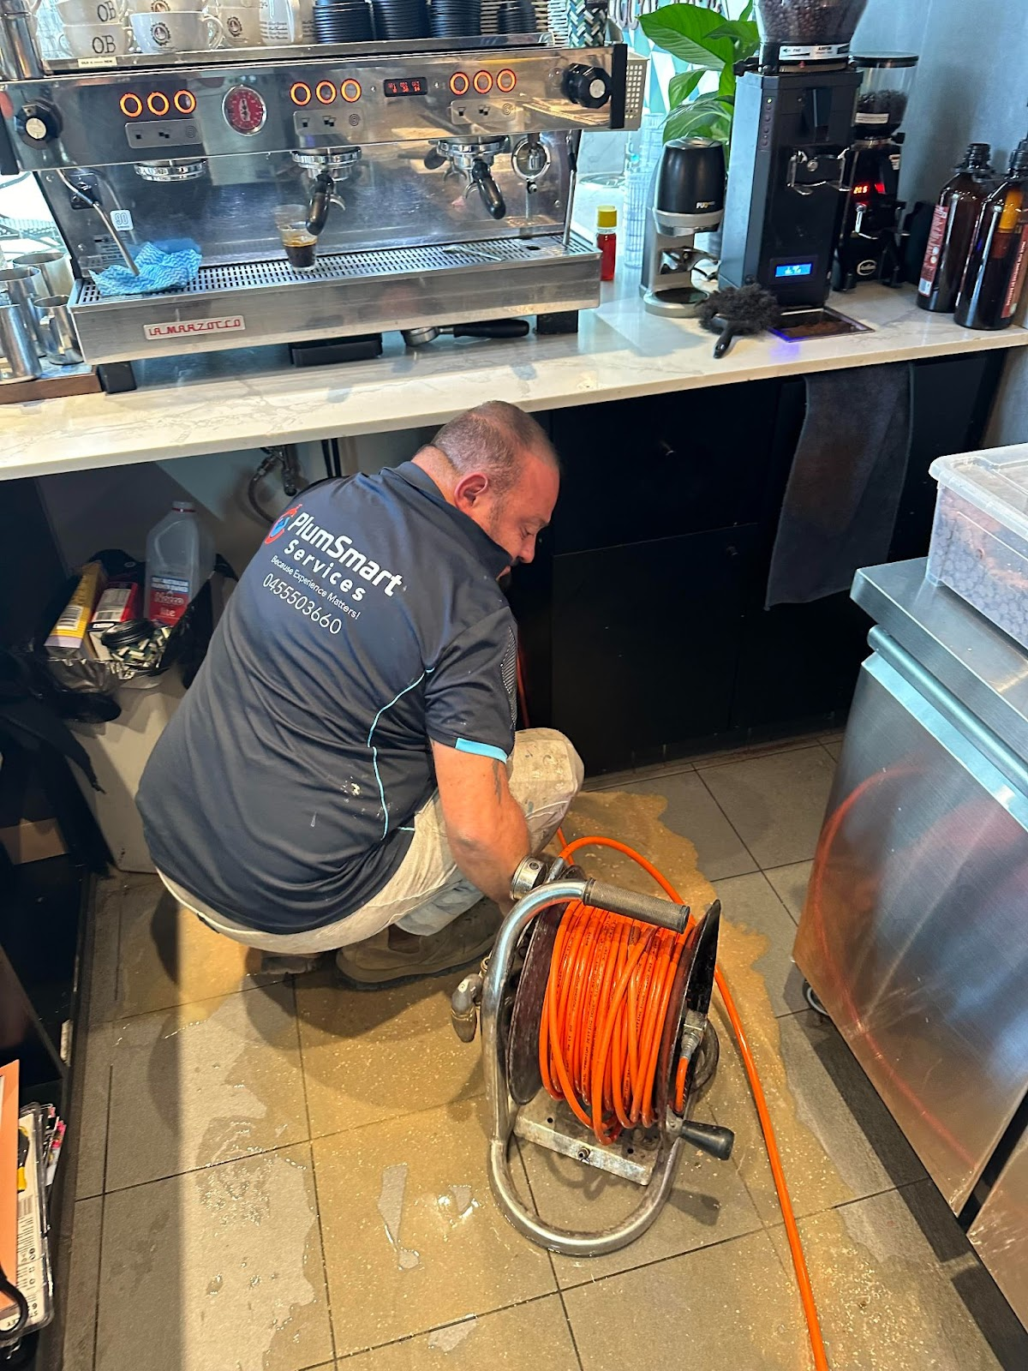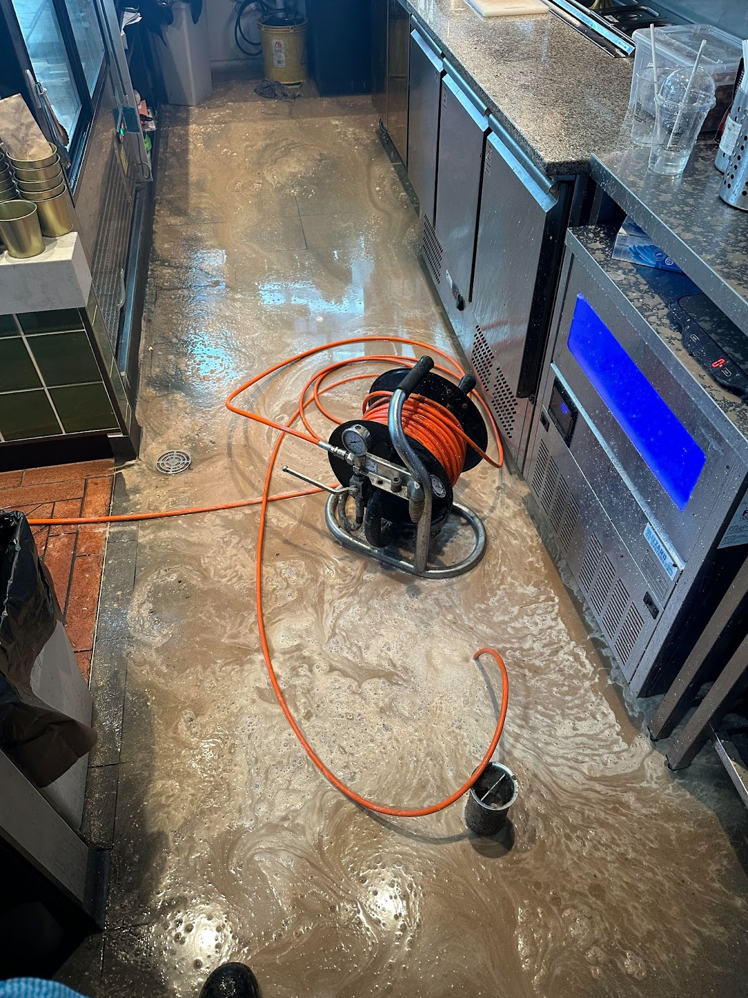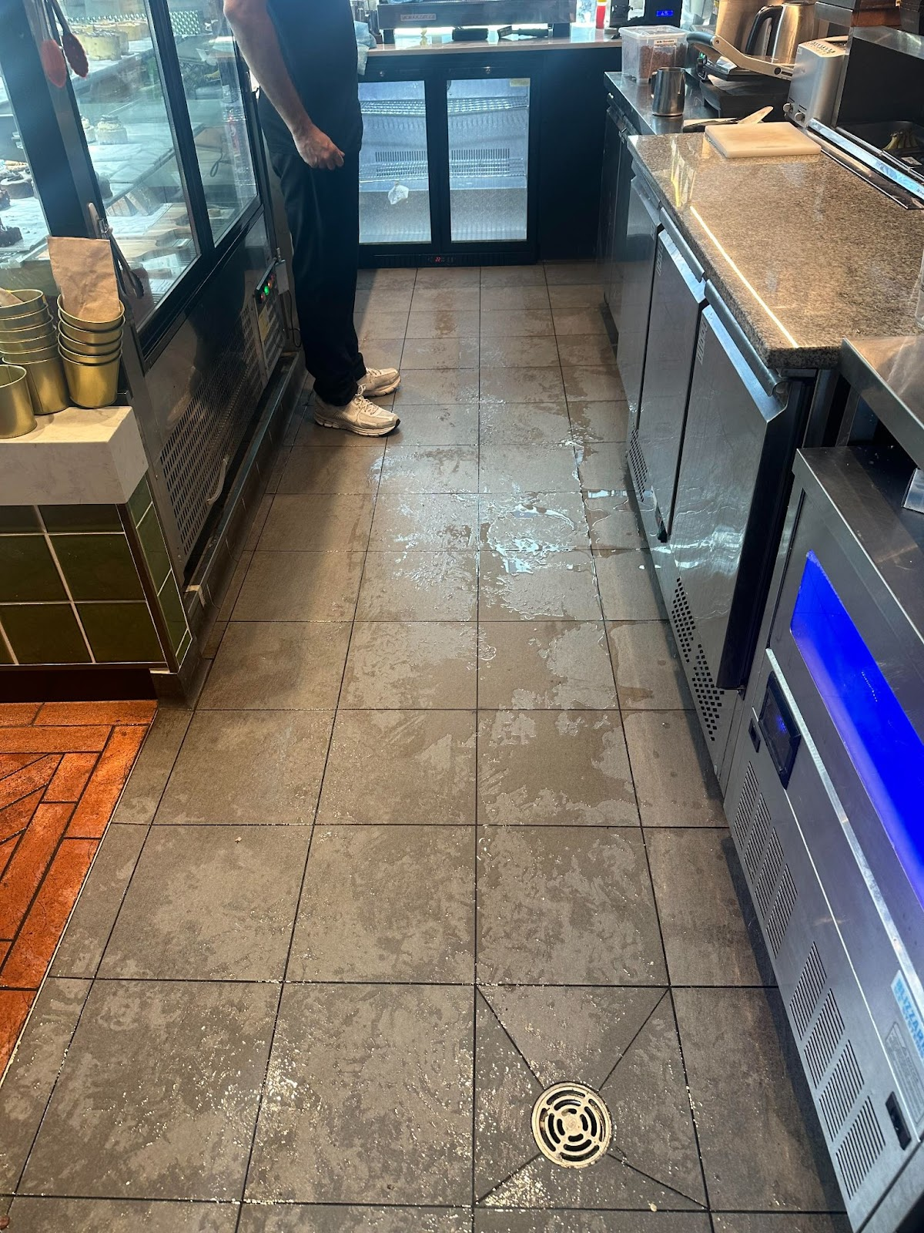

**Project 6: Bathroom Plumbing Repair – [Location]**

* **Client Type: Residential**
* **Project Overview: *A homeowner was dealing with a persistent leak in bathroom . We quickly diagnosed the problem  using (red black) dye as a leak around the shower screen started to show that was causing the leak existing the bathroom into the hallway  We replaced the old silicone with new clear bathroom and kitchen silicone  ensure a leak-free system.***
* **Challenges: *Careful removal and reinstallation of silicone around the shower screen without damaging the surrounding tile floors and wall tiles***
* **Duration: *3***
* **Outcome: *Leak resolved, saving the homeowner from potential water damage.***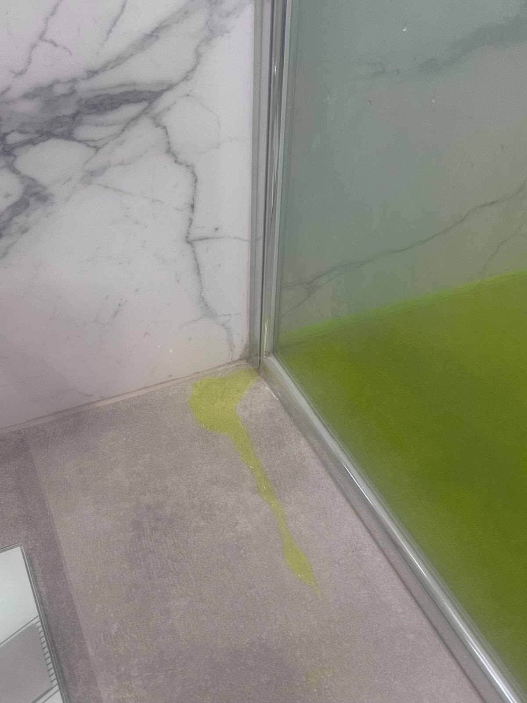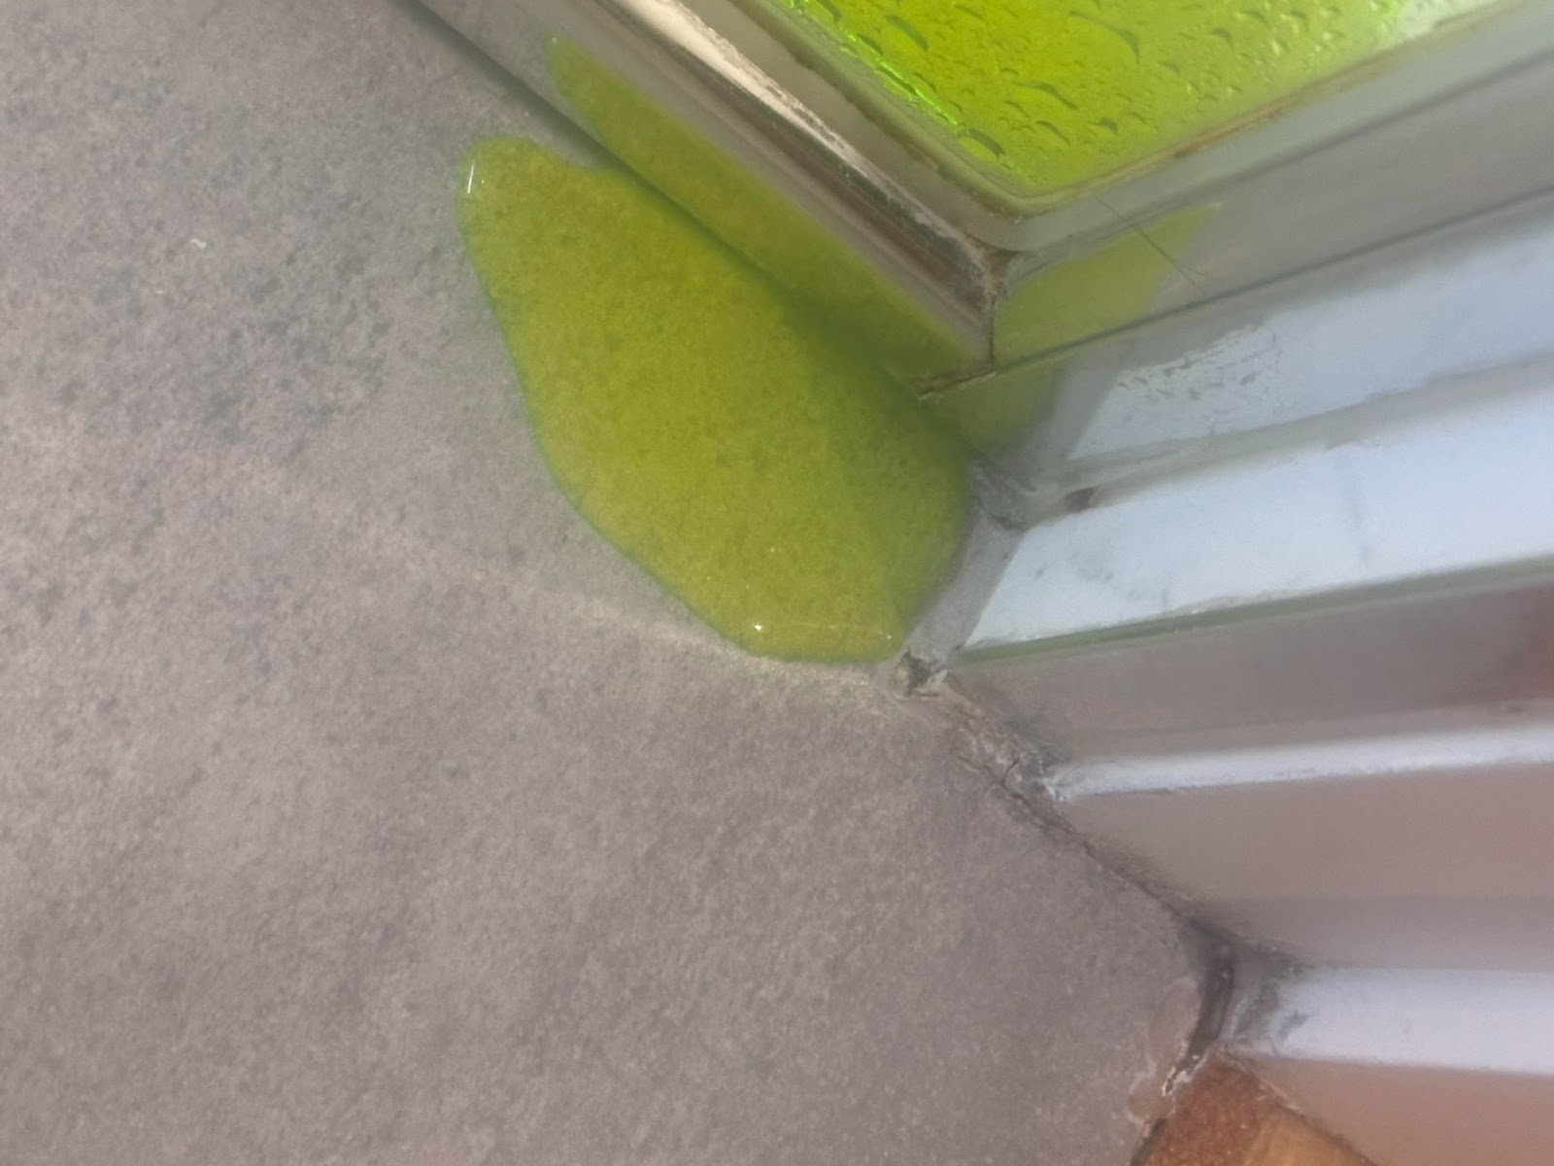

**Call to Action**

***"Have a plumbing project you need help with? Contact PlumSmart Services to discuss your needs and get a free estimate!"***

**4: Price listing  - Button on Home page**

**BLOCKAGE STARTING FROM 150 PLUS GST**

**HOTWATER HEATER PLACEMENT SUPPLY AND INSTALLTION**

**STARTING FROM 950 PLUS GST**

**TOILET REPLAMENT SUPPLIED AND INSTALLED**

**STARTING FROM 750 PLUS GST**

**HYDRO JETTING / JET BLASTER WITH CAMERA**

**STARTING PRICE 450 PLUS**

**CAMERA INSPECTION WITH REPORT**

**STARTING PRICE 6OO PLUS GST**

**DOWNPIPE INSTALLATION SUPPLY AND INSTALL**

**ROUND PVC OR ROUND COLOUR BOND (ONLY)**

**STARTING PRICE 160 PLUS GST**

**BATHROOM ACCESSORIES EACH HOUSE**

**STARTING PRICE 1300 PLUS GST**

**Third Button to be Request a Quote**